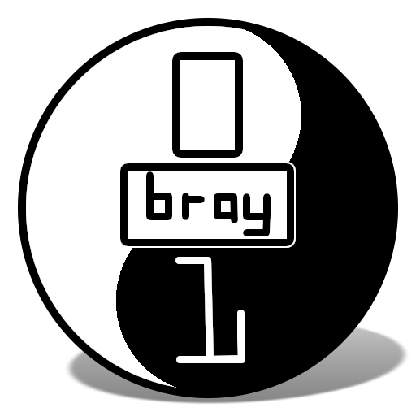
CoderDojo Bray: Week 3
Writing games and animations with MIT Scratch

This lives online here: http://goo.gl/zn4XC

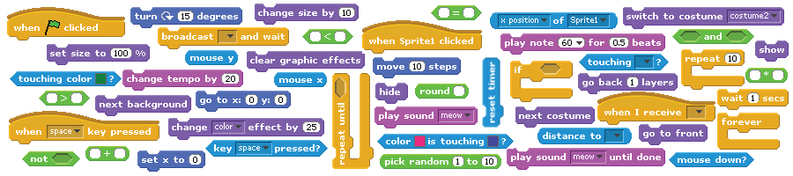

Developed by the ScratchEd team and released under a Creative Commons license.

Links

You may be interested in viewing or downloading these projects/examples.

Type | Description | Link
Video | Intro to Scratch video | http://vimeo.com/29457909
Video | Dance #1 | http://vimeo.com/28612347
Video | Dance #2 | http://vimeo.com/28612585
Video | Dance #3 | http://vimeo.com/28612800
Video | Dance #4 | http://vimeo.com/28612970
Project | About me | http://scratch.mit.edu/projects/ScratchEdTeam/2041660
Project | Dance party | http://scratch.mit.edu/projects/ScratchEdTeam/2041671
Project | Square, circle | http://scratch.mit.edu/projects/ScratchEdTeam/2042075
Project | Build-a-band | http://scratch.mit.edu/projects/ScratchEdTeam/2042276
Project | Automatic drawing | http://scratch.mit.edu/projects/ScratchEdTeam/2042282
Project | Conversation | http://scratch.mit.edu/projects/ScratchEdTeam/2042349
Project | Scenes | http://scratch.mit.edu/projects/ScratchEdTeam/2042673
Project | Slideshow | http://scratch.mit.edu/projects/ScratchEdTeam/2042695
Project | Debug it #1 | http://scratch.mit.edu/projects/ScratchEdTeam/2042697
Project | Debug it #2 | http://scratch.mit.edu/projects/ScratchEdTeam/2042703
Project | Debug it #3 | http://scratch.mit.edu/projects/ScratchEdTeam/2042706
Project | Debug it #4 | http://scratch.mit.edu/projects/ScratchEdTeam/2042712
Project | Debug it #5 | http://scratch.mit.edu/projects/ScratchEdTeam/2042724
Project | Maze | http://scratch.mit.edu/projects/ScratchEdTeam/2042736
Project | Maze Extension: Score | http://scratch.mit.edu/projects/ScratchEdTeam/2042755
Project | Maze Extension: Timer | http://scratch.mit.edu/projects/ScratchEdTeam/2042761
Project | Maze Extension: Enemies | http://scratch.mit.edu/projects/ScratchEdTeam/2042763
Project | Maze Extension: Levels | http://scratch.mit.edu/projects/ScratchEdTeam/2042764
Project | Maze Extension: Rewards | http://scratch.mit.edu/projects/ScratchEdTeam/2042770
Project | Collide | http://scratch.mit.edu/projects/ScratchEdTeam/2042778
Project | Catlibs | http://scratch.mit.edu/projects/ScratchEdTeam/2042781
Project | Scrolling | http://scratch.mit.edu/projects/ScratchEdTeam/2042861
Gallery | Sample Scratch projects | http://scratch.mit.edu/galleries/view/137903
Gallery | Sample arts projects | http://scratch.mit.edu/galleries/view/138296
Gallery | Sample stories projects | http://scratch.mit.edu/galleries/view/138297
Gallery | Sample games projects | http://scratch.mit.edu/galleries/view/138298
Gallery | Maze extensions | http://scratch.mit.edu/galleries/view/138300
Gallery | About me sample projects | http://scratch.mit.edu/galleries/view/138381
Gallery | Dance party sample projects | http://scratch.mit.edu/galleries/view/138382
Gallery | Maze sample projects | http://scratch.mit.edu/galleries/view/138299

BUG #3
Alex wants his cat to dance to some music. But the cat is dancing after the music is over! What’s going on?

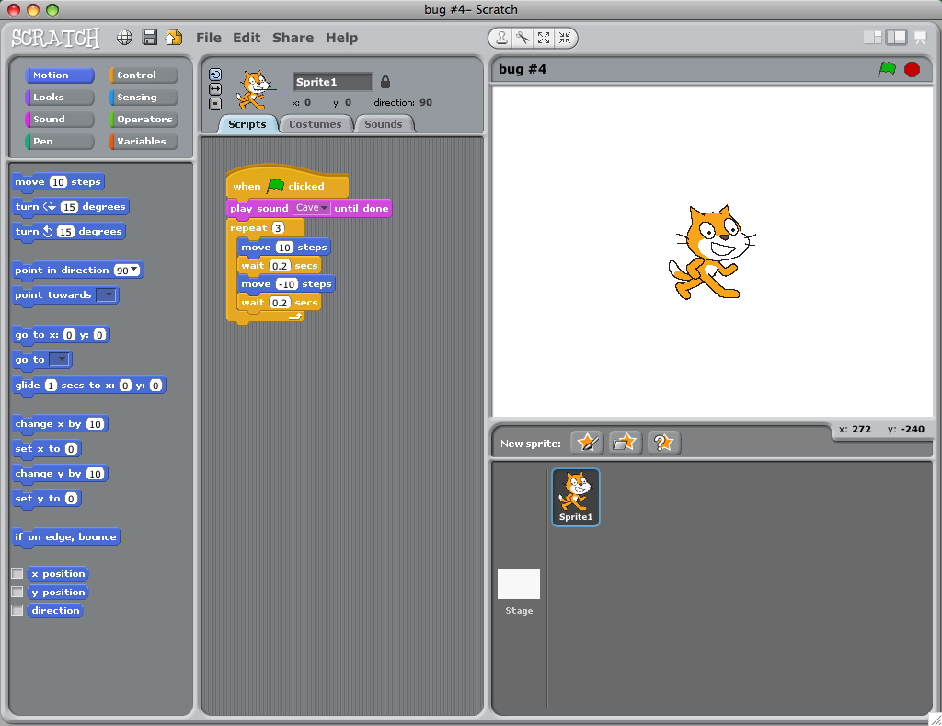
BUG #4
Praneetha wants to control the cat’s x-position with the keyboard: right arrow moves the cat right, left arrow moves the cat left. She also wants the cat to say if it’s on the right side or the left side, depending on its x-position. The cat’s moving, but not saying its position correctly! What’s going on?

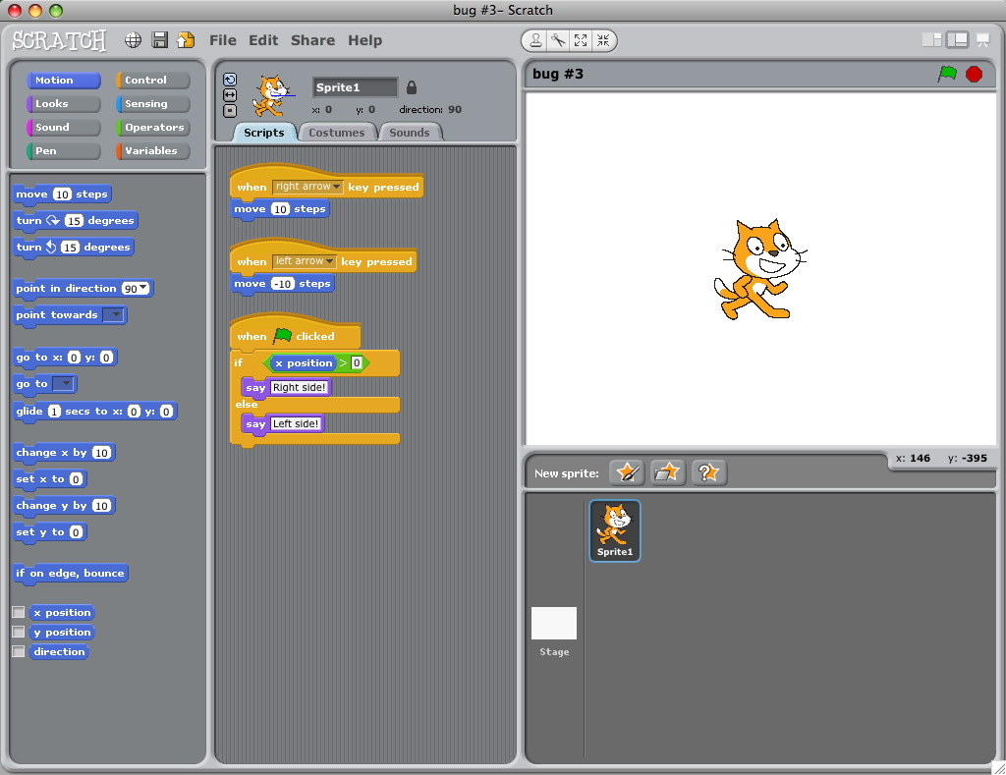
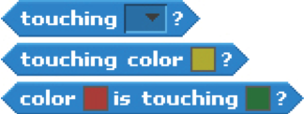

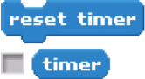

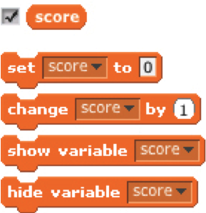
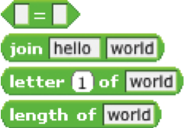
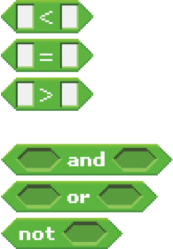
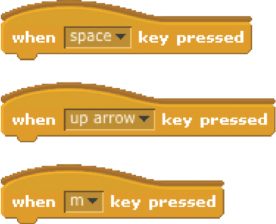
GAMES
Here are some blocks that can be useful in games.
TOUCHING
Get a computer-generated number
from within a specified range
See if two sprites are touching or
if a sprite is touching a color
Make a sprite appear or disappear
RANDOM
TIMING
STRINGS
VISIBILITY
KEY PRESS
COMPARE
VARIABLES
Store a number or string in a
container to access later
Test, access, and change words
and sentences
Have the computer keep track of
time for you
Make a sprite respond when different keys are pressed
Compare values to help make
decisions within your game
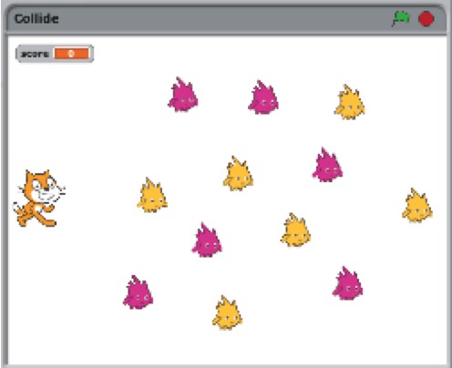
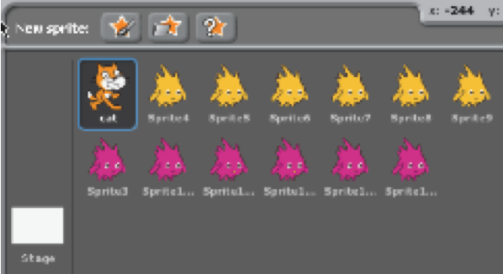
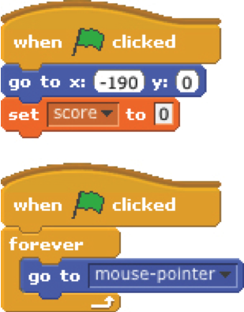
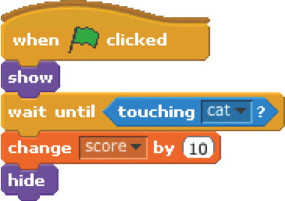
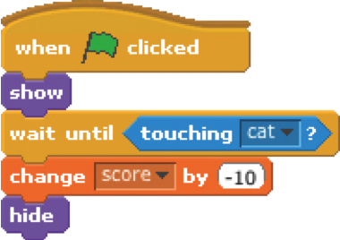
COLLIDE
Help the cat navigate a field of Gobos. Collect yellow gobos to earn points,
avoid pink gobos to avoid losing points.

reset the cat’s position
and the score
when the cat collides with a
yellow gobo, the gobo disappears
and the score increases by 10
no scripts

when the cat collides with a
pink gobo, the gobo disappears
and the score decreases by 10
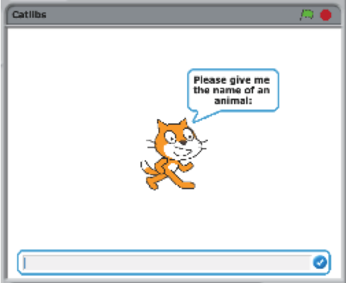
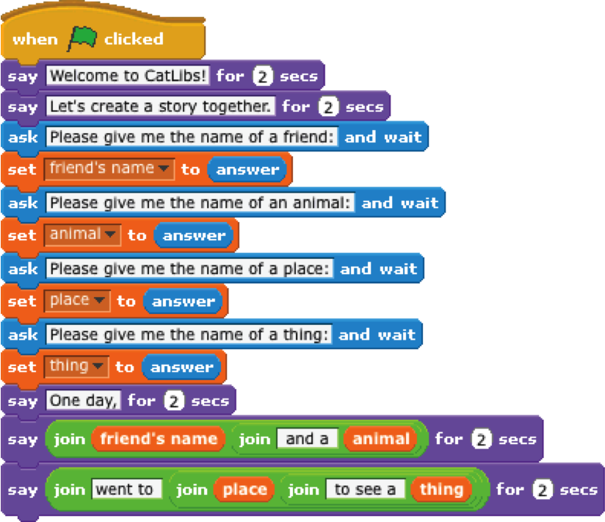
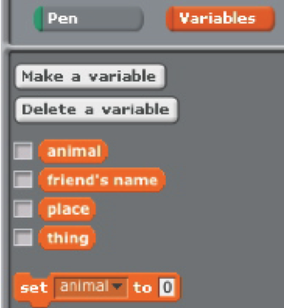
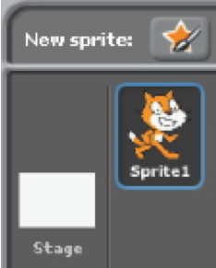
CATLIBS
Create a unique Madlib story by collecting user input.
no scripts

1 script
4 variables

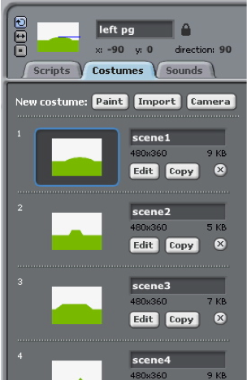
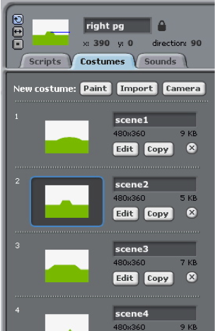
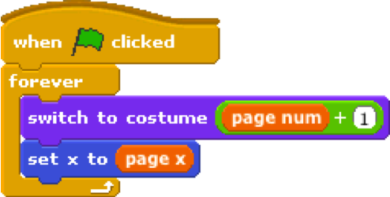
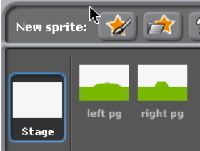
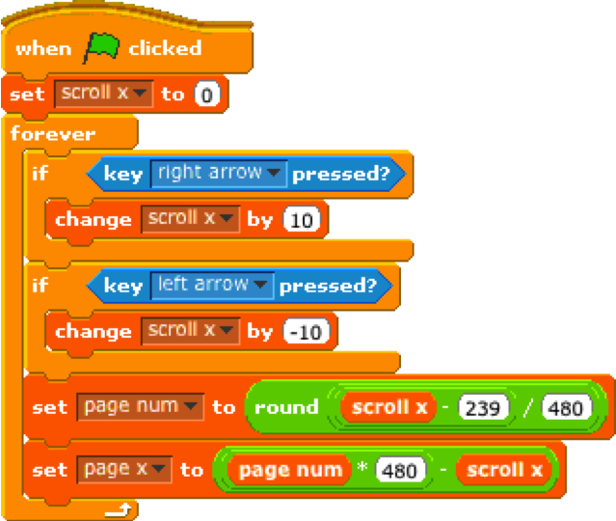
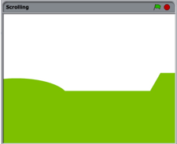
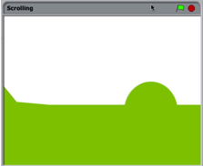
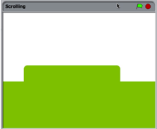
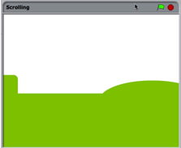
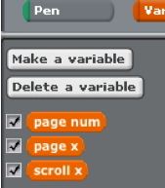
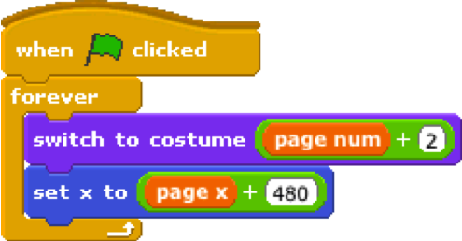
SCROLLING
Create the
foundation
for a side
scrolling
game.
create two sprites:
one for the left background panel,
one for the right background panel

add the same (2 or more) costumes to each sprite

add this script to the left sprite

add this script to the right sprite

3 variables

1 script

SENSING

Controlling a game with an Android phone

Connections between Scratch and other programs are made using the Scratch networking protocol. With this feature turned on, Scratch automatically sends all broadcasts and values of global variables out to any program connected to it. That program can also send broadcasts and global variables into Scratch. The Scratch Sensor is an Android app that uses the Scratch networking protocol to turn the Android Smartphone into a DAQ module and sends its accelerometer and compass sensor information and broadcast two states (jump and walk) to Scratch.

- Download Scratch Sensor from the Android Market.

- Download the example Scratch project.

- Note your Computer IP Address. Click the Start icon in the Windows taskbar. Paste cmd /k ipconfig into the search bar and press Enter. The screenshot shows the IP Address for the Wireless Network is 192.168.1.2.

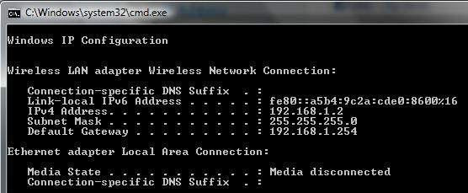

- Load the example Scratch project. A Remote sensor connections enabled dialog should appear. Click OK. Click the green flag to Start.

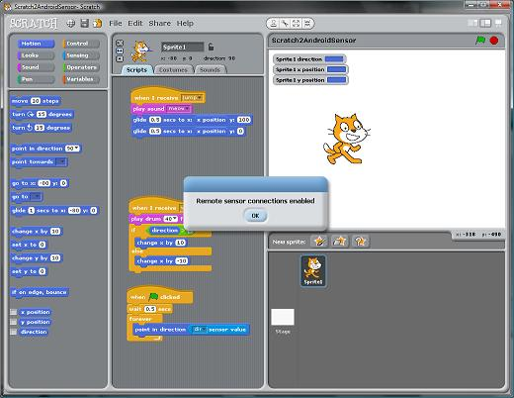

- Start Scratch Sensor on your Android smartphone. If your smartphone wifi is not enabled, you need to enable it now. Enter your Computer IP Address that you obtained earlier. Press the Connect Button. You should see a Connected status.

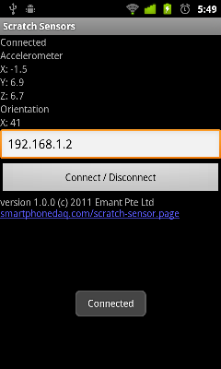

- Hold the Android Smartphone in an upright position. When you rotate the phone, the direction value should change. The sprite faces only left and right due to the sprite setting (see Scratch programming).
- When the phone is moved up and down, the jump message is broadcast.
- When the phone is moved side to side, the walk message is broadcast.

To find out more, see: http://www.smartphonedaq.com/scratch-sensor.page

